DAP Caching & Redis Architecture (Draft v0.1)
Oct 12, 2026 · @Rahul Pandey

Summary and principles
DAP should cache aggressively on the read and display path — reference data, routing, token metadata, projections, decoded views — and never let a cache answer a question that moves money: spendable balance, policy verdict, nonce, whitelist state, key material. Redis runs as two separate per-cell clusters: an evictable cache cluster and a durable, non-evicting state cluster for idempotency, replay protection, rate limits and sessions.
This doc applies to the DAP target state described in the architecture review and the BFF doc (cells per shard, sub-ledger as sole writer, CQRS projections, event backbone). All TTLs below are proposed starting values to validate under load testing.

Principles
- Correctness over latency on the money path. Anything read by the PDP, TX Service or co-signer to authorise or sign comes from the system of record, or from a cache entry that is content-addressed and therefore immutable.
- Cache is never a system of record. Losing all of Redis must cost latency, never data or money. The only exception — the state cluster — is still reconstructable or safely fail-closed.
- Prefer immutable, versioned keys. Key by content hash or version (policy bundle v42, H(Tr)), so invalidation becomes unnecessary for the most sensitive data.
- Event-driven invalidation, TTL as the safety net. Changes publish on the event backbone; TTL bounds staleness if an event is missed.
- Tenant isolation holds in the cache too. Cache layout follows cell and shard boundaries; no key, cluster or ACL ever spans two BUs.
- Every cached read is observable. Hit ratio, staleness (as_of) and evictions are first-class metrics with SLOs.

Caching tiers
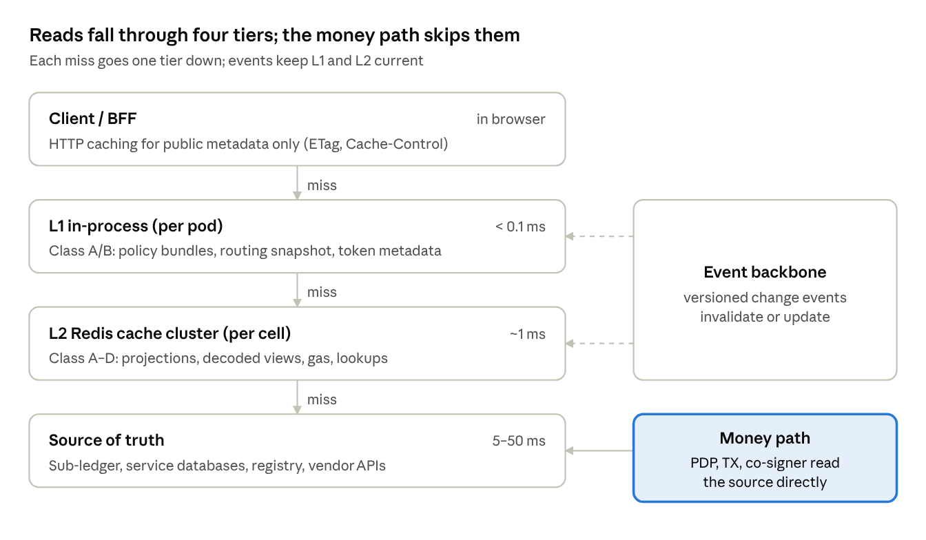
caching tiers · read path vs money path
A read tries the nearest tier first and falls one tier down on each miss; change events from the backbone keep L1 and L2 current, while the PDP, TX Service and co-signer read the source of truth directly. Latencies are indicative orders of magnitude.
- L0 — client / BFF. HTTP caching only for non-sensitive, public metadata (chain and token lists) with ETag; all account data is Cache-Control: no-store.
- L1 — in-process. A bounded, TinyLFU-style cache per pod (e.g. ristretto or otter in Go) for class A/B data. Sized in entries and bytes, never unbounded. Kept fresh by pushed snapshots or Redis server-assisted client-side caching (RESP3 CLIENT TRACKING), with a short TTL as backstop.
- L2 — Redis cache cluster. Shared per cell; holds every cacheable family including projections for BFF reads.
- Source of truth. Sub-ledger and projection stores, service databases, Platform Registry, custody vendor APIs.

What to cache
Cacheable data falls into four classes, and the class — not the service — decides pattern, TTL and how strictly it must be invalidated.
Class | Meaning | Default treatment
A — Immutable | Never changes once written (content-addressed or append-only) | Cache freely, long TTL, no invalidation needed
B — Slow reference | Changes rarely, by admin action | L1 + L2, event invalidation, hours-scale TTL
C — Display state | Changes often; shown to humans, never used to authorise | L2 (+ short L1), event-updated, seconds-scale TTL, response carries as_of
D — Volatile market / chain | Changes every block or tick | L2 only, very short TTL, refreshed by a poller

Cache matrix
Data | Owner service | Class | Tier | Pattern | Proposed TTL | Invalidation
Chain metadata (chain id, confirmations rule, explorers) | Blockchain Service | B | L1 + L2 | Read-through | 24 h | chain.updated event
Token metadata (contract, decimals, standard, chain) | Token Service | B | L1 + L2 | Cache-aside | 24 h | token.updated (TOKEN_UPDATE)
Platform fee schedule | Platform Fee Service | B | L1 + L2 | Read-through, versioned key | 1 h | fee.schedule.published
Routing snapshot (tenant → shard → entry points) | Platform Registry | B | L1 (pushed) + L2 | Versioned snapshot push | 5 min fallback | registry.snapshot.v{n} push
Compiled policy bundle | PAP / PDP | A | L1 | Keyed by bundle version + hash | Until superseded | New version = new key
JWKS / BFF and service public keys | IAA | B | L1 | Read-through, refetch on unknown kid | 10 min | Rotation event + kid miss
Vault account ↔ vendor id mappings | Wallet Service | A | L1 + L2 | Cache-aside | 24 h | None (immutable)
Deposit address → account lookup (inbound webhooks) | Wallet Service | A | L2 | Cache-aside, warmed on creation | 7 days | None; addresses are never reassigned
Decoded tx view + simulation result | Co-signer decoder | A | L2 | Write-once keyed by H(Tr) | Approval expiry (e.g. 30 min) | None (content-addressed)
Entitlements / roles for display filtering | IAA | B | L1 + L2 | Cache-aside with version stamp | 60 s | iaa.role.changed, revocation pushes
Positions projection (display) | Sub-ledger projections | C | L2 | Event-updated (write-through from consumer) | 5 s soft / 60 s hard | ledger.posting events
Tx status / timeline by ref_id | TX Service projections | C | L2 | Event-updated | 1 h active, 24 h after final | tx.status events
Approvals queue per approver | PDP projections | C | L2 | Event-updated | 5 s | approval.* events
Screening result per address (display, pre-check) | Screening | C | L2 | Cache-aside | 15 min | List-update event flushes all
Gas / fee estimate per chain | Blockchain Service | D | L2 | Poller refresh | 5–15 s (chain dependent) | Overwritten by poller
Chain head / finalized height | Blockchain Service | D | L2 | Poller refresh | 1–2 s | Overwritten by poller
Oracle / market price (display only) | Oracle Service | D | L2 | Poller refresh | 1–5 s | Overwritten by poller
TTL values assume no events are missed; the TTL is the worst-case staleness bound, not the normal one.

What never to cache
If a stale value could let money move that should not, or block money that should, it is read from the system of record every time.
Data | Why never cached | Read instead from
Spendable balance / reservation for a transfer | A stale balance allows overdraw or double-spend across concurrent intents | Sub-ledger, inside the reservation transaction
Policy verdicts and decision tokens | Bound to one intent and one tx hash; reuse is a replay | PDP evaluation per stage (the bundle is cached, the verdict is not)
Signing-stage sanctions / screening check | Lists change intraday; signing must use the current list | Screening service, synchronous
One-time whitelist entries (cross-shard) | Must be consumed exactly once and revoked atomically | Policy Service store
Chain nonces | Stale nonce = stuck or replaced transaction | Custody vendor / nonce manager
Key material, key shares, API secrets, signing keys | Secrets never leave HSM / KMS / TEE boundaries | HSM, KMS, co-signer enclave
Raw or signed transactions (Tr, Ts) | Evidence, not cache; must be durable and immutable | Tx store + WORM audit
Approval votes and quorum state | Authoritative governance record | PDP store
API-key revocation decisions for write calls | A revoked key must stop working immediately | IAA (revocations also pushed to L1 deny-list)
Client PII (names, tax ids, addresses) | Data-protection exposure, retention rules | Client master systems, fetched and masked per request

Grey areas — allowed with guardrails
- Positions for display are cached (class C), but every response carries as_of, and a transfer passes that as_of to the PDP, which reserves against the ledger. The cache can make a screen stale; it cannot make a transfer wrong.
- Entitlements are cached for view filtering only. Admin, policy and high-value actions bypass the cache and re-check IAA.
- Screening results are cached for UX and early rejection; the signing-stage check is always fresh.

TTL strategy
TTLs come from a small set of named bands, always carry jitter, and distinguish a soft TTL (refresh in background) from a hard TTL (must not serve).

TTL bands
Band | Soft TTL | Hard TTL | Used for
T-TICK | — | 1–5 s | Chain head, gas estimates, display prices
T-LIVE | 5 s | 60 s | Positions, approvals queue
T-SHORT | 30 s | 60 s | Entitlements for display
T-SESSION | — | 15 min idle / 8 h absolute (per firm policy) | BFF sessions
T-MEDIUM | 5 min | 15 min | Screening display results, routing snapshot fallback
T-LONG | 1 h | 24 h | Token and chain metadata, fee schedule
T-IMMUTABLE | — | 24 h – 7 days (memory bound only) | Content-addressed and append-only data
T-STATE | — | Business retention (24–72 h) | Idempotency records, replay nonces (state cluster)

Rules
- Jitter on every TTL. Set TTL × (1 ± 10%) randomly so keys written together do not expire together and stampede the source.
- Soft / hard TTL (stale-while-revalidate). Store fresh_until inside the value and set the Redis TTL to the hard TTL. Between soft and hard, serve the cached value and trigger one background refresh. Past hard, the key is gone and the reader goes to source.
- Probabilistic early refresh for hot keys (XFetch: refresh when now − Δ·β·ln(rand()) ≥ expiry) so the busiest keys renew before they expire.
- Negative caching. Cache "not found" for lookups that are attacked or retried (unknown address, unknown kid) with a short TTL (10–30 s) and a distinct marker value, so a later create is visible quickly.
- TTL in config, not code. Bands are defined centrally and overridable per environment and per tenant, with every change audited.
- Never PERSIST on the cache cluster. Every key in the cache cluster has a TTL; a key without one is a bug and is alerted on.

Cache patterns and invalidation
Each key family uses exactly one write pattern, and only the owning service's cache updater ever writes or deletes its keys.
Pattern | Use for | DAP examples
Cache-aside (lazy load) | Class A/B lookups with unpredictable access | Token metadata, vendor id mappings, deposit-address lookup
Read-through (SDK loader) | Reference data read by many services | Chain metadata, fee schedule, JWKS
Event-updated (write-behind from events) | Class C projections | Positions, tx timeline, approvals queue
Write-once, content-addressed | Immutable artefacts | Decoded tx view keyed by H(Tr), compiled policy bundle by version
Poller refresh | Class D volatile data | Gas estimates, chain head, display prices
Pushed snapshot | Small, hot, versioned config | Routing snapshot, entitlement version stamps
Write-through from request handlers is not used: it couples request latency to Redis and creates dual-write races with the database.

Event-driven invalidation
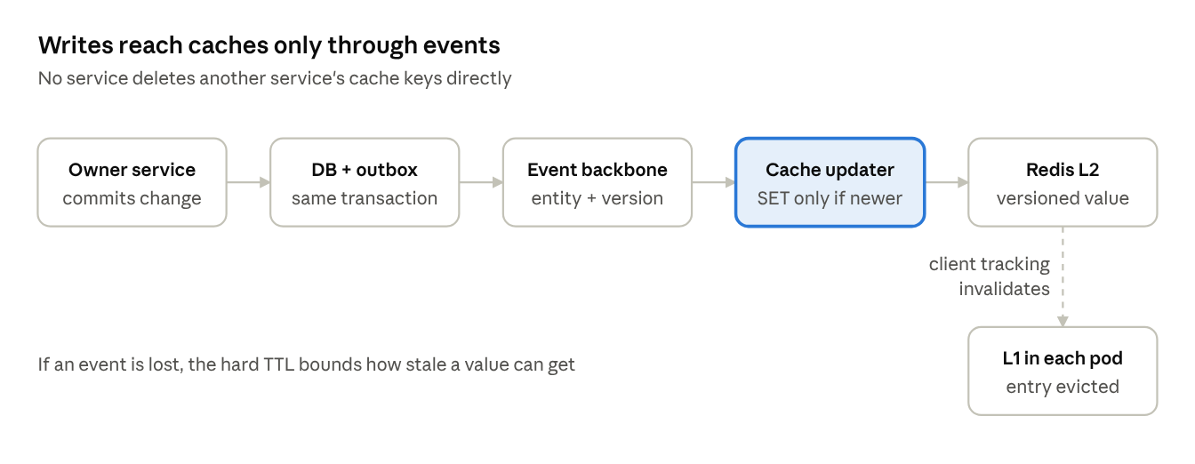
event-driven invalidation · owner to L1
The owner commits the change and an outbox row in one transaction; the event carries entity id and source_version; the cache updater writes the new value (or deletes the key) through a Lua compare-and-set that only applies if the incoming version is newer, so out-of-order events cannot regress a value. Redis server-assisted client-side caching then evicts the affected L1 entries in every pod.

Stampede and hot-key protection
- Request coalescing: singleflight per key per pod, so one miss produces one source call regardless of concurrency.
- Cross-pod coalescing for expensive loads: short SET lock:{key} NX PX 3000 lease; losers wait briefly and re-read the cache (efficiency only, never correctness).
- Soft TTL + XFetch early refresh for hot keys; jitter on all TTLs.
- Warm-up of class A/B families on deploy and after flushes, rate-limited against the source.
- Hot keys absorbed by L1; if a single key exceeds a shard's budget, replicate it under N suffixed keys and read one at random.

Redis beyond caching (state cluster)
Five non-cache uses justify Redis on the state cluster; each must fail closed and none may be the only record of a financial fact.
Use | Structure | Key / TTL | Failure behaviour
Idempotency of intents and webhooks | SET key value NX EX ttl storing request hash + response | idem:{tenant}:{ref_id}, 72 h | Fail closed: reject the write (retry later) rather than risk a duplicate transfer
Wiring-protocol replay protection | SET nonce NX EX | rp:{kid}:{nonce}, 2 × signature window | Fail closed at the dispatcher edge
Rate limiting and quotas | Token bucket or sliding window in one Lua script (atomic) | rl:{tenant}:{principal}:{route}, window | Fail closed for writes, fail open for reads with local limiter
BFF sessions (token handler) | Hash with encrypted token set | sess:{bff}:{sid}, idle + absolute TTL | Users re-authenticate
Short-lived coordination leases | SET lock NX PX + fencing token | lease:{scope}:{id}, seconds | Lease lost → work stops

Idempotency, done properly
- On receipt, SET idem:{tenant}:{ref_id} {state:IN_PROGRESS, req_hash} NX EX 259200.
- If the key exists with the same req_hash, return the stored response (or 409 in progress). A different req_hash with the same ref_id is a client error (422).
- On completion, overwrite with {state:DONE, response} keeping the TTL.
- The database still enforces uniqueness on ref_id. Redis is the fast path; the DB constraint is the guarantee if Redis loses a write during failover.

Locks: use with care
Redis locks (including Redlock) cannot guarantee mutual exclusion across process pauses and failovers. For DAP they are acceptable only as efficiency leases (avoid two pollers doing the same work). Anything financial — nonce assignment, ledger postings, whitelist consumption — relies on database transactions, unique constraints or the custody vendor, and lease holders pass a fencing token that the downstream store checks.

Event fan-out
Kafka remains the event backbone. Redis Pub/Sub may be used inside a cell for BFF push fan-out (SSE nodes subscribe to push:{tenant}:{user}), because it is fire-and-forget. Missed messages are recovered from the projection on reconnect, never from Redis.

Key design and tenant isolation
One key grammar across DAP, with the tenant inside a Redis Cluster hash tag so a tenant's related keys co-locate and can be operated on atomically.

Key grammar
dap:{env}:{cell}:{svc}:{entity}:v{schema}:{{tenant}}:{id}
e.g.
dap:prod:wm-us1:wallet:depaddr:v2:{wm}:0x8f3a…c21
dap:prod:wm-us1:tx:timeline:v1:{wm}:ref_01J9…
dap:prod:wm-us1:codec:decoded:v1:{wm}:sha256:7be1…
- v{schema} changes when the value format changes, so deploys never read an old shape (old keys simply age out).
- {tenant} hash tag keeps a tenant's keys on one slot range, allowing multi-key Lua scripts per tenant. Watch for one tenant becoming a hot shard; split the tag ({wm:0}…{wm:7}) for very large tenants.
- Short keys at scale. Prefixes are fixed by the shared SDK; avoid free-form strings.

Values
- Protobuf (same schemas as the wiring protocol) with a small envelope: {schema_version, written_at, fresh_until, source_version, payload}. source_version lets readers reject a value older than one they have already seen.
- Compress values above ~1 KB (LZ4 / zstd); hard cap 512 KB per value; anything bigger is mis-modelled.
- Hashes for objects with independently updated fields; avoid collections that grow without bound (big keys block the event loop on delete — use UNLINK).

Tenant isolation
- Physical: a separate Redis cluster per cell (shard × environment × region). WM, ISG and IM never share a cluster.
- Logical: Redis ACL users per service with key-pattern restrictions (~dap:prod:wm-us1:wallet:*) and command allow-lists.
- No cross-tenant aggregation in Redis. Firm-wide views are built from events in an analytics store, not by scanning caches.

Redis deployment topology
Each cell runs two Redis Cluster deployments — cache and state — spread across three availability zones, with only the state cluster replicated to the DR region.
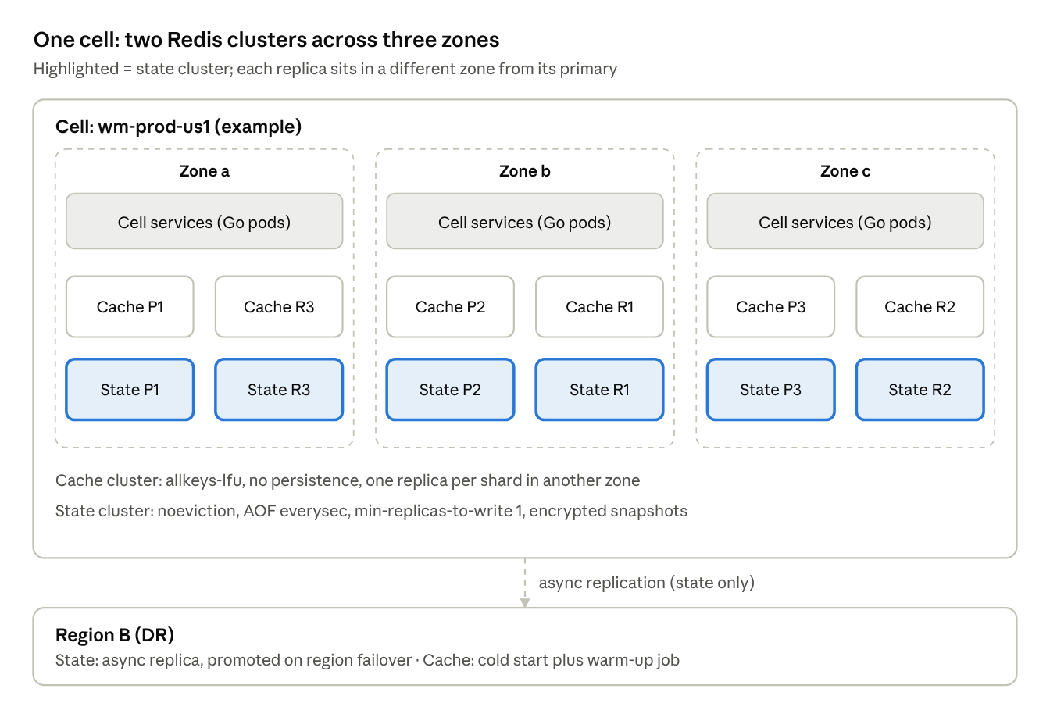
Redis topology · one cell, 3 zones, DR region
Shard counts are illustrative; size per the capacity section.

Cluster configuration
Setting | Cache cluster | State cluster
Purpose | Evictable cached data (classes A–D) | Idempotency, replay nonces, rate limits, sessions, leases
maxmemory-policy | allkeys-lfu | noeviction
Persistence | None (or RDB for faster warm restart) | AOF everysec + periodic RDB to encrypted storage
Replicas | 1 per primary, different zone | 1–2 per primary, different zones
min-replicas-to-write | 0 | 1
Cross-region | None; DR region starts cold and warms | Async replica; promoted with the cell on region failover
Failure stance | Fail open | Fail closed for writes
Every key has TTL | Mandatory | Mandatory (business retention)

Multi-region and DR
- Cells are regional; there is no active-active Redis across regions for DAP state. Active-active CRDT replication is reserved, if ever, for low-risk display caches.
- On region failover, the state replica is promoted with the cell. Writes lost in the async gap are caught by database unique constraints on ref_id, so a retried intent cannot double-execute.
- Proposed recovery objectives: cache RTO = time to warm class A/B (minutes), RPO not applicable; state RTO < 15 min, RPO ≤ replication lag, with DB constraints as the correctness backstop.

Hosting options
Option | Fit | Notes
Redis Enterprise / Redis Software (on-prem or private cloud) | Strong for firm data centres | Commercial support, Active-Active option, RBAC, audit
Managed cloud (e.g. ElastiCache, MemoryDB, Azure Managed Redis) | Strong if DAP cells run in cloud | MemoryDB-style durable multi-AZ logs suit the state cluster
Valkey on Kubernetes (operator-managed) | Possible for lower environments | Team owns patching, failover testing and upgrades

Security controls
Redis is treated as a Tier-1 data store inside the custody boundary, even though nothing secret is ever written to it.
- Encryption in transit: TLS 1.2+ (prefer 1.3) for client and replication traffic; mutual TLS with workload certificates for service clients.
- Encryption at rest: disk-level encryption for RDB/AOF and snapshots; snapshots stored in encrypted, access-controlled buckets.
- Authentication and authorisation: no default user; one ACL user per service per cell with least-privilege key patterns and command lists; credentials from the firm secrets manager, rotated automatically.
- Dangerous commands disabled or renamed: KEYS, FLUSHALL, FLUSHDB, CONFIG, DEBUG, MODULE, SCRIPT FLUSH; SCAN only for operations tooling.
- Network: private subnets only, no public endpoints; Kubernetes network policies allow only the owning cell's namespaces.
- Data minimisation: no secrets, key material, PII or full client identifiers; account references are internal ids. Classification of each key family is recorded in the key registry.
- Lua scripts versioned in source control, loaded at deploy (SCRIPT LOAD / functions), reviewed like code; no ad-hoc EVAL from applications.
- Audit: ACL log and admin-command audit shipped to the SIEM; break-glass access to production Redis via privileged access management with session recording.
- Licensing check: Redis moved from BSD to source-available licences in 2024 and added an AGPLv3 option with Redis 8 in 2025; Valkey is the Linux Foundation fork. Confirm the approved distribution (Redis Enterprise, a managed cloud service, or Valkey) with legal and engineering standards.

Failure modes and resilience
The cache cluster fails open (slower, still correct); the state cluster fails closed for writes (safer, temporarily unavailable). Every service declares which behaviour applies to each key family.
Failure | Detection | Cache cluster behaviour | State cluster behaviour
Node or primary loss | Sentinel / cluster failover, client topology refresh | Brief misses; reads go to source behind bulkheads | Writes paused during failover (seconds); clients retry with backoff on ref_id
Full cluster outage | Circuit breaker opens after error-rate threshold | Serve from L1 (stale-if-error up to hard TTL), then source with rate-limited load | Reject new intents with 503 retry-after; reads continue
Latency spike | p99 client latency > budget | Client timeout (e.g. 20 ms) then source; never block a request on cache | Timeout then fail closed
Memory pressure | used_memory / maxmemory > 80% | LFU eviction (by design) | noeviction → OOM errors → alert P1, fail closed
Cold start / flush | Hit ratio drop | Warm-up job pre-loads class A/B keys; request coalescing protects source | Rebuild not possible for in-flight idempotency → DB unique constraint is the backstop
Missed invalidation event | Version check, staleness metric | Bounded by hard TTL; consumer lag alert | n/a
Hot key | Per-key ops metric, --hotkeys sampling | L1 absorbs reads; split or replicate key | Shard the tag
Split brain after partition | Cluster quorum (min-replicas-to-write) | Possible stale reads, bounded by TTL | min-replicas-to-write 1 limits lost writes; DB constraint is the backstop

Client settings (Go services)
- Pooled cluster client (go-redis or rueidis), connect timeout 100 ms, command timeout 20–50 ms by key family, max 1 retry for reads, none for non-idempotent writes.
- singleflight around every source fetch; circuit breaker per cluster; bulkhead limiting concurrent source calls on cache miss.
- Readiness probes must not depend on the cache cluster (a cache outage must not take pods out of rotation).

Observability, SLOs and capacity
Cache health is measured per key family, because one blended hit ratio hides the family that is hurting the source.

Proposed SLOs
Metric | Target | Alert
Client-side p99 latency (cache cluster) | < 2 ms in-cell | > 5 ms for 5 min
Hit ratio, class A / B families | > 95% | < 85% for 15 min
Hit ratio, class C families | > 80% | < 60% for 15 min
Staleness (now − written_at) on class C reads | p99 < 5 s | > 30 s
Invalidation consumer lag | < 1 s | > 10 s
Memory used vs maxmemory | < 70% | > 80%
Evictions on state cluster | 0 | any
Keys without TTL on cache cluster | 0 | any
Replication lag | < 100 ms | > 1 s

Telemetry
- Client metrics via OpenTelemetry: hits, misses, latency, errors, payload size — labelled by key_family, never by full key.
- Server metrics: memory, fragmentation ratio, evictions, expired keys, connected clients, slowlog, LATENCY monitor, replication offset.
- Dashboards per cell; runbooks linked from every alert.

Capacity sizing
For each key family: memory ≈ live_keys × (avg_key_bytes + avg_value_bytes + ~80 B overhead); sum across families, then add 30% headroom for fragmentation and failover, and size per primary so that no single shard exceeds ~25 GB (faster failover and resync). Ops capacity: plan for 2× peak QPS with one node lost. Validate both with production-shaped load tests per cell before go-live.

Production readiness and open questions

Readiness checklist
- ☐ Every key family registered (owner, class, tier, TTL band, invalidation event, data classification)
- ☐ Never-cache list enforced in code review and by a static check on the shared SDK
- ☐ Separate cache and state clusters per cell; noeviction + AOF on state, allkeys-lfu on cache
- ☐ TLS, ACL users per service, dangerous commands disabled, secrets rotated
- ☐ DB unique constraints back every idempotency and replay check
- ☐ Invalidation consumers deployed with lag alerts; version-stamped values
- ☐ Stampede protection (singleflight, jitter, soft TTL) on all class B/C families
- ☐ Failover drill: primary kill, full cluster loss, AZ loss — results recorded
- ☐ Load test at 2× peak with one node down; memory and latency within SLO
- ☐ Dashboards, alerts and runbooks live; on-call trained
- ☐ Approved Redis distribution and licence confirmed

Open questions for the team
- ☐ Which Redis distribution is firm-approved (Redis Enterprise on-prem, a managed cloud service, Valkey)?
- ☐ Does DAP run on-prem, in cloud, or both — and are there residency constraints on cached data?
- ☐ Is there an existing firm caching SDK or key-registry standard to adopt?
- ☐ What are year-1 read QPS and key counts per cell, to size the first clusters?
- ☐ Should BFF sessions share the state cluster or get their own?

